Name: Mamata kc

Sec:A

Roll no:5805

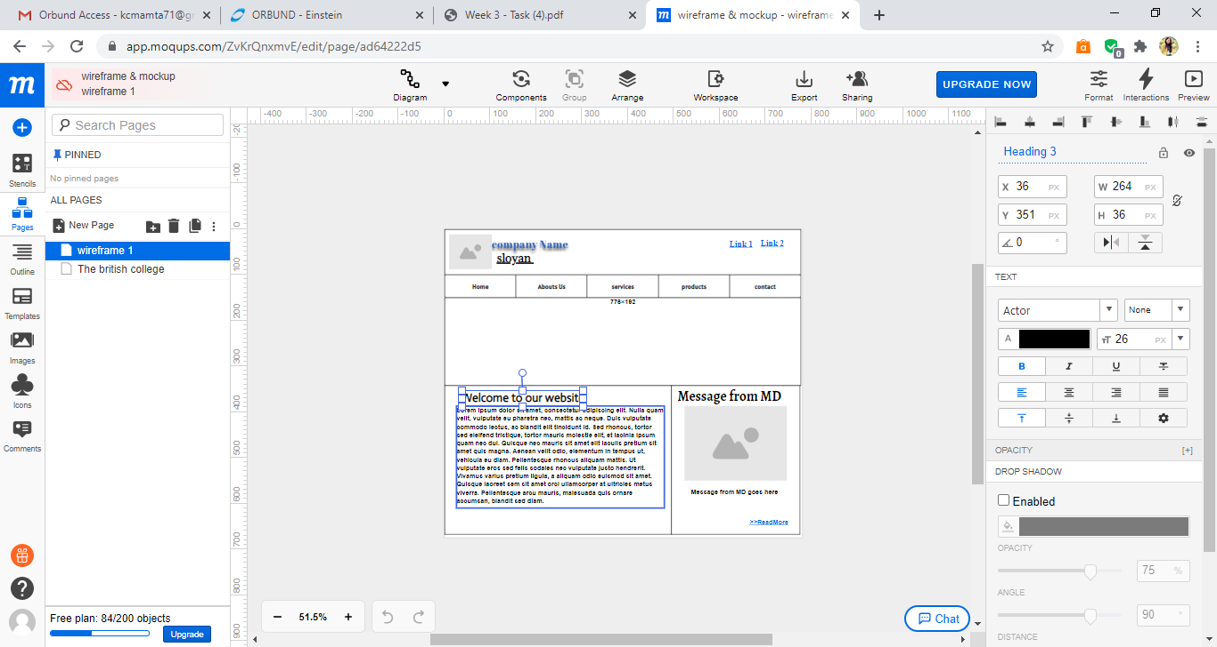

<https://app.moqups.com/ZvKrQnxmvE/edit/page/ad64222d5>

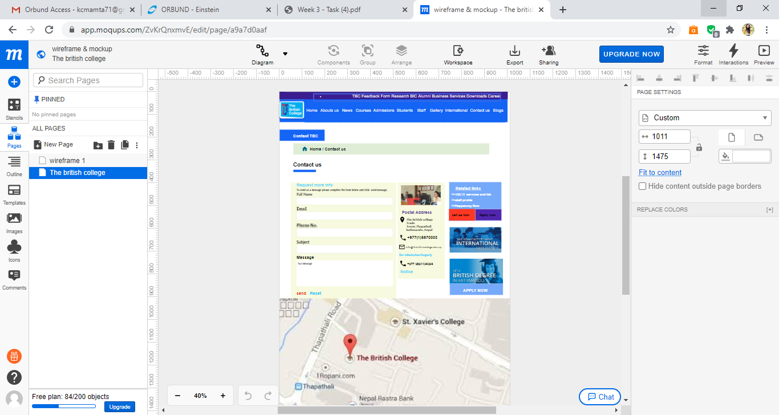

<https://app.moqups.com/ZvKrQnxmvE/edit/page/a9a7d0aaf>